CROYDON COUNCIL - Job Description

Job title:  Corporate Director of Resources  (S151) | Service Area:  Resources
Directorate:  Resources | Post Number  C14480
Grade:  5 | Date issued:  August 2025

Mayor’s Business Plan and Council priorities

The Mayor’s business plan: 2022 to 2026 has five outcomes:

- The Council balances its books, listens to residents and delivers good sustainable services.
- Croydon is a place of opportunity for business, earning and learning.
- Children and young people in Croydon have the chance to thrive, learn and fulfil their potential.
- Croydon is a cleaner, safer and healthier place, a borough we’re proud to call home.
- People can lead healthier and independent lives for longer.

Overall purpose of role

As a member of the Council’s corporate management team, the Corporate Director of Resources will work collaboratively with other corporate directors and the chief executive to deliver the Mayor’s Business Plan, Future Croydon the Transformation Plan and a financially sustainable Council.

The Corporate Director of Resources will provide high quality professional advice to the Executive Mayor and Cabinet, the Scrutiny and Overview Committee, the Audit & Governance Committee, Pensions Committee and any other Council or external bodies on all matters related to financial and legal, and commercial functions of the Council.

The Corporate Director of Resources will directly lead and manage a portfolio of financial, non Housing property, commercial and legal services and promote the corporate competencies and values through day-to-day leadership and managerial behaviours.

Reports to: chief executive

Status: this post is equivalent in status to the corporate director posts of
Children, Young People & Education, Adult Social Care & Health, Housing,
Sustainable Communities, Regeneration and Economic Recovery and the
post of Assistant Chief Executive.

Responsible for: the Council’s legal service, democratic services & scrutiny,
strategic planning and management of the Council’s finances including the
general fund, housing revenue account and the capital programme, internal audit,
external audit, risk managment, anti-fraud, insurance, treasury management,
payments, revenues, benefits & debt, the Croydon Council Pension Fund, capital
programme delivery for school and Council assets, asset and facilities
management, health and safety, procurement, Council investments in other entities,
companies and shareholdings.

Job context:
The post incorporates the statutory role of Section 151 of the Local Government Act 1972.

To act as the deputy chief executive and deputy head of paid service in the absence of the chief executive.
The postholder is required to observe and fulfill the seven principles of public life (also known as the Nolan Principles).
  - Selflessness

Holders of public office should act solely in terms of the public interest.

1.2 Integrity
Holders of public office must avoid placing themselves under any obligation to people or organisations that might try inappropriately to influence them in their work. They should not act or take decisions in order to gain financial or other material benefits for themselves, their family, or their friends. They must declare and resolve any interests and relationships.

1.3 Objectivity
Holders of public office must act and take decisions impartially, fairly and on merit, using the best evidence and without discrimination or bias.

1.4 Accountability
Holders of public office are accountable to the public for their decisions and actions and must submit themselves to the scrutiny necessary to ensure this.

1.5 Openness
Holders of public office should act and take decisions in an open and transparent manner. Information should not be withheld from the public unless there are clear and lawful reasons for so doing.

1.6 Honesty
Holders of public office should be truthful.

1.7 Leadership
Holders of public office should exhibit these principles in their own behaviour. They should actively promote and robustly support the principles and be willing to challenge poor behaviour wherever it occurs.

The post holder has line management responsibility for 6 direct reports, overall responsibility for 514 staff in the directorate and is accountable and responsible for all financial and legal services delivered and the overall Council’s financial system including the Council’s general fund, housing revenue account, capital budget and the delivery of the capital programme (non- highways & HRA).

The post holder is accountable for the financial, property and legal services directorate budget. The post holder will deliver services and the associated savings programme and transformation projects within the directorate budget envelope.

The post holder will ensure the financial probity and competence of financial management within the directorate and across the Council as a whole and that effective arrangements are in place to meet legislative and statutory requirements in relation to financial management and internal control both corporately and within all directorates.

The post holder is jointly accountable with the corporate management team for the delivery of the Council’s equality strategy and will lead elements of it and champion it overall.

The post holder will ensure the corporate parenting responsibilities for the Council’s looked after children and care leavers are fulfilled in accordance with the Children and Social Work Act 2017.

The post holder will participate in the Council’s emergency arrangements as an on-call member and will fully participate in gold and silver arrangements as required, which may require chairing the formal Council meetings.

The postholder is required to deputise for the chief executive in the role of London local authority gold at a borough level as required.

The post holder will ensure that all relevant health & safety legislation and the Council’s health & safety requirements are reasonably complied with.

The post holder will be required to operate within the delegations from the chief executive and head of paid service and as detailed in the Council’s scheme of delegation of the Council’s constitution.

The post holder will be required to work some evenings, weekends and occasional public holidays in order to meet service requirements and to ensure appropriate representation of the Council with residents, the Leader and Cabinet, all elected Members and external bodies.

This is a politically restricted post under the Local Government and Housing Act 1989 and the Local Government Officers (Political Restrictions) Regulations 1990.The individual holding this post cannot have any active political role.

Politically restricted employees are prohibited from:
- standing for office as local Councillors, MPs, MEPs, Members of the Welsh Assembly or Members of the Scottish Parliament,
- canvassing on behalf of a political party or a person who is, or seeks to be, a candidate, and
- speaking to the public at large or publishing any written or artistic work that could give the impression of advocating support for a political party.

Accountabilities – Corporate Director of Resources

To provide direction, leadership and guidance to staff in the finance and legal functions and ensure the continuous improvement and full adherence to legal best practice standards and and financial management best practice standards by cost centre managers across the Council.

To ensure the provision of a high quality legal service that is compliant with national local government best practice standards such as Lexcel and which safeguards and stewards the Council’s and residents’ interests and ensures compliance with the law and best practice, controlling the access to and use of external legal advice and expenditure on legal advice across the Council.

To ensure the provision of a high quality, cost effective, finance service that secures the best approach to resource stewardship for the Council’s budget, finances and services and that the Council complies with the requirements of the CIPFA Financial Management Code 2020.

To model and enforce a culture of rigorous challenge to non-essential expenditure, and model and ensure an approach of cost consciousness and delivery of value for money in all services.

To ensure that overall management attention, effort and controls are commensurate to risk and opportunity across the Council’s functions and ensure that Croydon residents’ interests are legally safeguarded and the Council operates within its legal powers and duties at all times.

To be the responsible and accountable officer for the development of financial and legal policy and strategies and the provision of professional advice on all matters relating to finance; advising the Executive Mayor and Cabinet, the Scrutiny and Overview Committee, the Audit & Governance Committee, Pension Board, Pension Committee, all Members, the chief executive, the corporate management team and others to enable the discharge of functions in an effective and efficient way, and to display the highest standards of ethical governance.

To lead the Council’s budget setting process, taking responsibility for designing and implementing a suitable process for engaging members and other stakeholders in budget decisions and arriving at an annual balanced budget.

To lead on the necessary medium and long term financial planning for the Council, ensuring effective financial monitoring and reporting to members and the corporate management and directorate management teams, taking responsibility for reporting on financial performance and highlighting issues and the actions required to deal with them.

To have responsibility for timely and accurate production of annual accounts and liaison with external auditor.

To take responsibility for monitoring and overseeing the overall affordability of the Council’s activities and the risks inherent in them, and ensuring that the Council operates within its affordability envelope.

To be responsible for meeting the needs of the organisation in terms of the quality and sufficiency of financial support services provided by the directorate, measuring and monitoring user satisfaction with services and benchmarking against similar organisations.

To ensure that the requirements of legislation and relevant statutory obligations and guidance affecting financial and legal services are identified and implemented, including appropriate staff training for staff both in the directorate finance and legal service and all cost centre managers across the Council.

To ensure the provision of a high quality finance business partner service to all directorates and cost centre managers to support their compliance with the financial reporting standards and management system requirements of the Council.

To ensure the Council’s treasury management strategy and management operations are in accordance with the approved policy and control procedures, and to ensure compliance with the CIPFA Code of Practice for Treasury Management in Local Authorities and the Prudential Code for Capital Finance in Local Authorities.

To ensure the provision of expert advice on investments and management of the fund to the Pensions Board and Pensions Committee and ensure the delivery of an effective Croydon Council Pension Fund service. To be responsible for the pension fund investments, ensuring that the pension service meets the needs of pensioners and existing and deferred members.

To manage the insurance and risk function, promoting risk management framework, regular reporting to members and senior management on the risk register to ensure Council assets are protected.

To ensure a coherent plan for the systemic and individual management of risk is in place and regularly maintained. Ensure that the risk management framework is adhered to and regular reporting to member bodies, the corporate management team, and directorate management teams takes place.

To ensure that effective specialist fraud advice and investigation skills are available to tackle irregularities that are raised both within and outside the Council in a manner that adheres to legislative frameworks and that a fraud awareness cuture is promoted within the Council to safeguard the interest of Croydon residents.

To ensure the delivery of an effective internal audit and anti- fraud function
providing reports to the Audit & Governance Committee, corporate management team and directorate management teams, closely liaising with the external auditor to the Council and supporting the receipt of the Annual Audit letter drawing it effectively to members’ attention for response and action.

To ensure the Council has effective arrangements for its internal financial controls and governance and that it complies with the statutory requirements relating to the Companies Act 2006, the Finance Act 1998 and the Employer’s (Compulsory Insurance) Act (E(CI)A) 1969.

To advise upon the capital investment strategy for the Council and once agreed, ensure a fully costed capital programme is in place and is delivered that supports the Mayor’s Business Plan and Future Croydon, the Tranaformation Plan with due regard to risk and health and safety.

To actively monitor and challenge the financial implications in all projects and programmes operating within the Council advising members and the corporate management team as appropriate.

To provide strategic leadership to and have accountability for managing the Council’s portfolio of external investments and shareholdings including the Revolving Investment Fund, the Asset Investment Fund, and act as corporate client to Brick by Brick Ltd, Croydon Affordable Housing, and the London Borough of Croydon Holdings Limited.

To provide strategic leadership to and ensure the provision of an effective
procurement service for all directorates.

To ensure adherence to Croydon Council’s Health and Safety Policy and all other relevant national legislation including the Health and Safety at Work Act 1974, the Management of Health and Safety at Work regulations 1999 and promote a culture supportive of effective health and safety good practice.

To ensure the development and delivery of an asset management strategy and disposals strategy for Council owned properties (non HRA) and the provision of cost-effective, safe and efficient facilities management and support services for Council staff and buildings.

Accountabilities (all corporate directors and service directors)

Tasks and accountabilities are intended to be a guide to the range and level of work expected of the post holder. This is not an exhaustive list of all tasks that may fall to the post holder and employees will be expected to carry out such other reasonable duties which may be required from time to time.

Strategy
To take a “one Council” approach to deliver more effective outcomes and at all times avoid a silo-ed, single directorate or service area approach.

To actively seek out and learn from external good practice and bring those new ideas and ways of working into service development and delivery.

To ensure the Council listens to and engages residents in the development of ideas, strategies and policies and that co-design and co-production approaches are implemented throughout the directorate.

To contribute fully to the development and implementation of all corporate strategies, the Mayor’s Business Plan and Future Croydon, the Transformation Plan, and to act as a project or programme senior responsible owner to lead and ensure the implementation of specific corporate projects as required.

To actively promote the Council’s leadership framework and values to ensure they are delivered throughout the organisation.

Service quality
To fulfil the best value duty requirements as established by the Local Government Act 1999 to make arrangements to secure continuous improvement in the way in which the directorate’s functions are exercised, having regard to a combination of economy, efficiency and effectiveness.

Through personal example, commitment and clear action, valuing and celebrating the diversity of Croydon’s communities, ensuring an inclusive approach and equality of access and treatment in employment and service delivery.

To develop appropriate service quality measures, targets and outcomes for
accountable assessment. To seek out more transparent accountability mechanisms for delivery in the directorate.

To maintain an up to date knowledge of relevant legislation as applicable to the directorate and to the overall Council.

To build effective partnerships to harness public, private, voluntary sector and community resources that can help deliver tthe Mayor’s Business Plan and Future Croydon, the Transformation Plan,

To be the Council’s (officer level) lead representative in a number of partnerships.

To work collaboratively with the trade unions to improve services and solve problems in a coherent and integrated manner.

Performance
To lead and direct the services within the directorate in order to ensure that they deliver effective and efficient services, that they set and achieve high standards of performance, that they provide best value and that the overall budgets are managed and controlled within the funding envelope agreed.

To lead, direct and uphold the internal control system that safeguards the residents’ interest in the appropriate use of Council resources and ensure the system is respected and complied with by all staff in the directorate.

To comply with the requirements of the Council’s constitution and the relevant officer and other codes of conduct and ensure through personal leadership that staff in the directorate are familiar with, understand and comply with the requirements also.

To ensure the effective management of data and security of information received and used within the directorate, to comply with the relevant legislation such as GDPR and the Freedom of Information Act, recognising that the Council wishes to operate in the most open and transparent way.

Resource management
To lead and direct an effective directorate management team.

To ensure that staff are informed, organised, performance managed, held to account and motivated to deliver high quality and cost effective services.

To uphold the mandatory financial regulations of the Council and ensure that they are understood and complied with by the directorate’s staff .

To plan and keep under review the services within the directorate to control the budgets within it, manage risk effectively and ensure accountability.

Leadership and Culture
To lead within the directorate and across the Council, the change that is needed in order to ensure that Resources services play their full part in achieving the the Mayor’s Business Plan and Future Croydon, the Transformation Plan,

To act at all times in ways that create a fully inclusive workplace and operating culture, proactively seeking ways to ensure staff feel valued and that they all belong.

To seek ways to harness and fully develop the potential of staff working in the directorate and develop their talent.

To demonstrate through personal behaviour, active listening to staff and residents in ways that will help rebuild the relationship with the residents of Croydon and seeking out the resident voice to guide and advise the Council in its’ actions and decision making.

To model the behaviours required of all staff in terms of equality, ethical behaviour, empathy, effective governance, effective internal control, transparency, and openness.

Leadership Framework

The Council’s leadership framework follows the principles of a competency framework and all staff are expected to demonstrate these.

Developing Oneself – You demonstrate the values every day, you are passionate about the services you lead and deliver the vision and outcomes of Croydon Council. You are inspirational and engage others through personal leadership making the vision understandable to everyone.

Inspiring and Developing People – You identify talent and develop their capability to ensure a committed and motivated workforce, you create a culture based on the corporate values and ensure staff and stakeholders deliver a desired outcome.

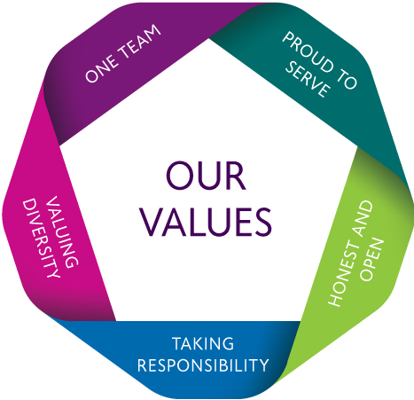
Collaborating and Influencing for Results – You are challenging and innovative in your approach to driving high standards and value for money, you trust and respect staff and partners and empower them to be courageous to try new approaches.

Enabling and Facilitating the Community – You create effective collaboration between stakeholders, establish relationships and understand others perspectives. You are open and honest with others. You build a shared sense of purpose across Croydon, ensuring delivery and a collective use of resources
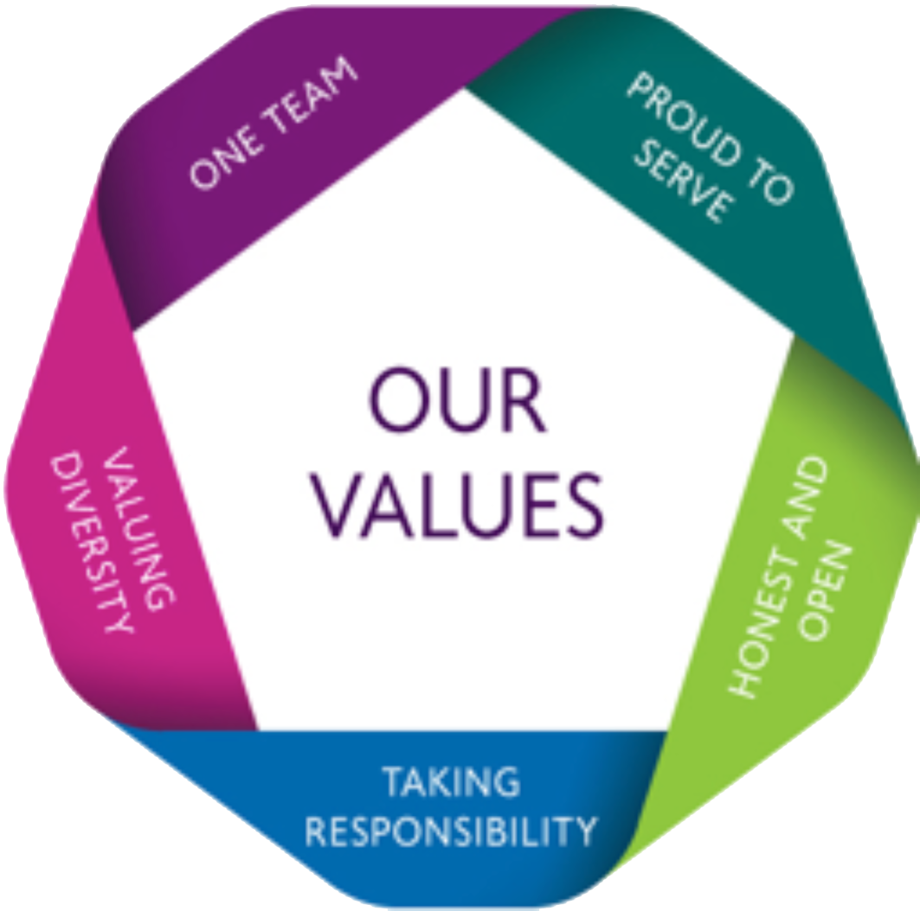
Corporate Values
Our values are the base of every job role within Croydon – our values are fundamental in everything we do as a Local Authority. You are required to demonstrate a commitment to our corporate values:

One Team: To cross boundaries to work together towards shared goals with colleagues, partners and communities
- You are strategically innovative in your approach to building and maintaining partnerships and you and your teams act in a joint enterprise with them. You use your contacts and colleagues to bring teams together.

Proud to Serve: We strive to always do our best for the community, getting the most from limited resources and using taxpayers’ money wisely
- You are proud to be part of the wider Croydon and the contribution you and your teams make to it. You make a difference to people’s lives through engagement and you strive to get the best possible value for money for customers.

Honest and Open: We work hard to build trust by treating everyone with honesty and integrity
- You think through who needs to understand what during communication; and take care to communicate detail clearly. You take people’s views into account continuously. You trust people, colleagues and staff, to do their best and deal with any issues positively.

Taking Responsibility: We encourage and support each other to take responsibility and show what we can do, learning together and recognising each others’ contributions
- You are clear where formal accountability lies and where we can all take responsibility for results. You praise your colleagues for their efforts and ideas and thank them for their contributions.

Valuing Diversity: We make the most of the many perspectives that make Croydon distinctive
- You treat all staff and customers with equal value and respect. In everything you do, you make good use of the wide variety of background, skills and perspective your teams, the Council and the community demonstrate.

